ON DEMAND TUTOR

DB:

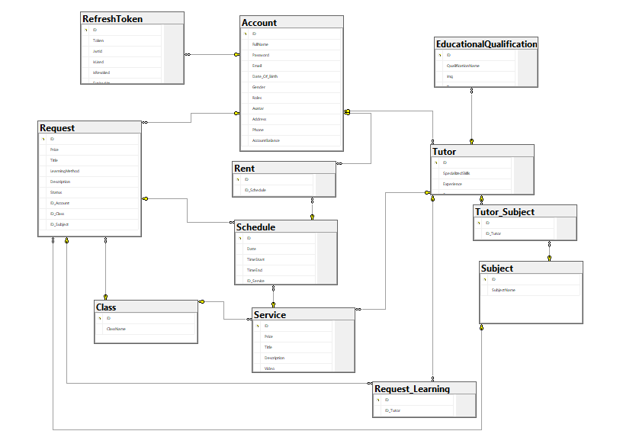

**SCREEN FLOW :**

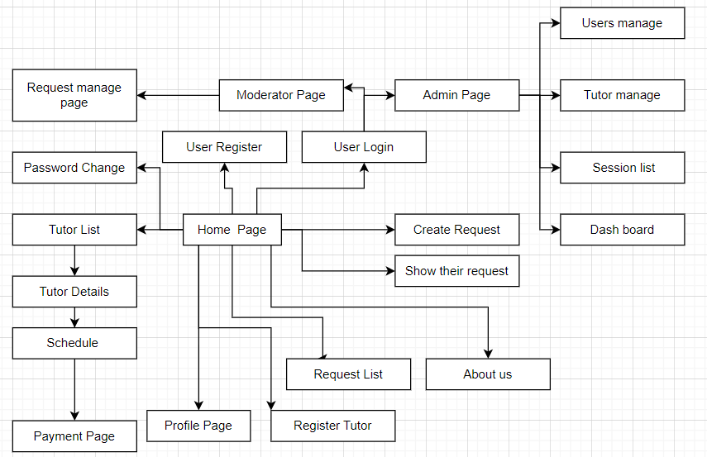

Technical Requirements (TRD)

Register

-Register with the exist email

# -Register with the correct information

Register as a tutor

# -Register tutor with the correct information

# -Register become a tutor without account

-Register tutor with non existent subject

Login

-Login with email and password must be correct

-Check email exist

-Login with password wrong

View Profile

Edit profile

Approved Tutor Profile

Reject Tutor Profile

View Profile’s Tutor

View Account

Delete Account

View the number of Request

View the number of Student

View the number of rental Tutor

Create Request

Join Request

Approved Request

Reject Request

Update Request

View Pending Request

View Approved Request

View Reject Request

View List Tutor

Create Complaint

Delete Complaint

View Complaint

View all tutor join request

Delete Request

UI  
Epic 👍

-

